Are Fat Stem Cells a Drug?

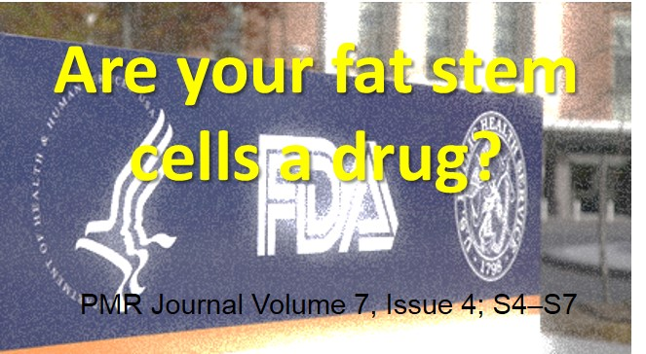
I’ve blogged before on the stem cell wild west, or the concept that there’s more misinformation on stem cells these days for patients and physicians than good information. Many colleagues act surprised when I tell them the FDA considers the stem cells that they are isolating from fat in their office an illegal unapproved drug. I then have to explain loads of information to them, so I thought that instead I’d write a blog post about the topic and give everyone a link.
First, so far, looking at all of the data published by FDA and the existing and planned regulations, same day stem cell procedures using bone marrow don’t seem to be impacted by any FDA rule changes. Second, for a much more detailed (and boring) technical discussion on the topic, see my recent paper published in the AAPMR journal. I’ve also published another similar paper in the same journal (link here). Third, I have long disagreed with the FDA’s position to regulate fat stem cells as a drug, as both papers describe. Having said that, the FDA gets to create the rules on this issue, so don’t kill the messenger.
So what’s the evidence that the FDA considers fat stem cells created at the bedside an unapproved drug? To understand this, you first have to understand that the agency created a “line in the sand” approach called “manipulation”. If what you do to cells crosses this line, then the cells (even those from the same patient and even if what you do occurs in the same surgical procedure in the doctor’s office) are considered a drug. The FDA began making it’s position clear on this issue in 2011. The agency was asked by physicians wishing to process fat at the bedside to obtain stem cells to treat knee arthritis whether the process would make the cells a drug or would covered under the “practice of medicine” (i.e. not a drug). As you can see from reading the FDA response linked above, the FDA considered the cells a drug. A very similar response was obtained when a Maryland plastic surgeon asked if fat processed in his office to obtain stem cells for a cosmetic procedure would be a drug.
If the two above letters left any doubt in anyone’s mind that the FDA considered fat stem cells a drug, more recently, the FDA has issued several draft guidances to spell out it’s position. The most recent documentseems to be aimed squarely at doctors who believe that processing the patient’s own fat stem cells in their office isn’t the manufacture of an illegal drug, but rather just the routine practice of medicine.
So here’s a quote from that document:
“Processing to isolate non-adipocyte or non-structural components from adipose tissue (with or without subsequent cell culture or expansion) is generally considered more than minimal manipulation. This is because the connective tissue and structural components of the adipose tissue are entirely removed from the non-adipocyte or non-structural isolates, thereby altering the original relevant characteristics relating to the tissue’s utility for reconstruction, repair, or replacement.”
Still not clear? Try this paragraph:
“Example A-1: Adipose tissue is recovered by tumescent liposuction. The adipose tissue undergoes processing or manipulation (e.g., enzymatic digestion, mechanical disruption, etc.) to isolate cellular components, commonly referred to as stromal vascular fraction, which is considered a potential source of adipose-derived stromal/stem cells for clinical therapeutic uses. This processing breaks down and eliminates the structural components that function to provide cushioning and support, thereby altering the original relevant characteristics of the HCT/P relating to its utility for reconstruction, repair, or replacement. Therefore, based on the definition of minimal manipulation for structural tissue, this processing would generally be considered more than minimal manipulation.”
I can just hear the peanut gallery now, shouting, “but wait, I’m still covered as a doctor under the same surgical procedure exemption (21 CFR 1271.15(b))! What does this mean? The FDA carves out an exemption from the drug regulations for doctors who minimally process tissue during the same surgical procedure.
How about this paragraph from the guidance:
“In regard to HCT/Ps from adipose tissue, we generally consider the exception in 21 CFR 1271.15(b) to apply only if the HCT/P from adipose tissue is for autologous use, is removed and implanted within a single operation or in a limited number of predetermined operations in order to achieve the intended effect, and does not undergo processing steps beyond rinsing, cleansing, or sizing. Limited handling such as rinsing and cleansing to remove debris would allow the HCT/P from adipose tissue to retain the structural function, while other processing steps such as cell isolation, cell expansion, or enzymatic digestion generally would not”
Enzymatic digestion is what’s needed to isolate fat stem, cells, hence the FDA says that this process is not covered under the same surgical procedure exemption. So that means that if the doctor isolates fat stem cells in his office, he/she is producing an unapproved drug.
I can hear the peanut gallery screaming, “But it’s still not a drug if it’s from the same patient!”. I hate to burst any bubbles or rain on the fat stem cell parade, but we have this example from the document:
“Example A-2: Adipose tissue is recovered by tumescent liposuction. Stem cells from the lipoaspirate are then isolated. Cell isolation would typically cause the adipose tissue to no longer be “such HCT/P.” Thus, even if this processed HCT/P from adipose tissue is injected into the same patient from whom it was removed during the same surgical procedure, the establishment would generally not be considered to qualify for the exception 323 under 21 CFR 1271.15(b).”
The upshot? While bone marrow stem cells for same day stem cell procedures are not considered a drug, the FDA is taking aim at doctors using fat stem cells in their offices. Regrettably, the doctors and lab people teaching weekend stem cell courses to doctors often tell physicians that fat stem cell processing is just fine with FDA. The above documents show otherwise.
By Chris Centeno|April 11th, 2015|Latest News, Regulation

